1 | ENGLISH | 1.CURSIVE WRITING  2.PEARLS  3.GRAMMAR &MORE | 1.ASIA BOOK HOUSE 2.RATNA SAGAR  3.RATNA SAGAR
2 | MALAYALAM | 1.MALAYALAM  2. PADAVALI 3.AKSHARA VAZHY | 1.PRIYA BOOKS  2.ASIA BOOK HOUSE
3 | HINDI | 1.HINDI PADAMALA  2.HINDI COPY | 1.ASIA BOOK HOUSE  2.ASIA BOOK HOUSE
4 | MATHS | 1.PEARLS | 1.RATNA SAGAR
5 | EVS | 1.PEARLS | 2.RATNA SAGAR
6 | COMPUTER | 1.TOUCH PAD | 2.ORANGE
Academic Session 2023-24 Class -1

Academic Session 2023-24 Class -2
1 | ENGLISH | 1.CURSIVE WRITING  2.PEARLS  3.GRAMMAR &MORE | 1.ASIA BOOK HOUSE 2.RATNA SAGAR  3.RATNA SAGAR
2 | MALAYALAM | 1.MALAYALAM  2. PADAVALI 3.AKSHARA VAZHY | 1.PRIYA BOOKS  2.ASIA BOOK HOUSE
3 | HINDI | 1.HINDI PADAMALA  2.HINDI COPY | 1.ASIA BOOK HOUSE  2.ASIA BOOK HOUSE
4 | MATHS | 1.PEARLS | 1.RATNA SAGAR
5 | EVS | 1.PEARLS | 2.RATNA SAGAR
6 | COMPUTER | 1.TOUCH PAD | 2.ORANGE

1 | ENGLISH | 1.CURSIVE WRITING  2.PEARLS  3.GRAMMAR &MORE | 1.ASIA BOOK HOUSE 2.RATNA SAGAR  3.RATNA SAGAR
2 | MALAYALAM | 1.MALAYALAM  2. PADAVALI 3.AKSHARA VAZHY | 1.PRIYA BOOKS  2.ASIA BOOK HOUSE
3 | HINDI | 1.HINDI PADAMALA  2.HINDI COPY | 1.ASIA BOOK HOUSE  2.ASIA BOOK HOUSE
4 | MATHS | 1.PEARLS | 1.RATNA SAGAR
5 | SCIENCE | 1.PEARLS | 2.RATNA SAGAR
6 | SOCIAL | 1.PEARLS | 2.RATNA SAGAR
7 | COMPUTER | 1.TOUCH PAD | 2.ORANGE

Academic session 2023-24
Class- 3

1 | ENGLISH | 1.CURSIVE WRITING  2.PEARLS  3.GRAMMAR &MORE | 1.ASIA BOOK HOUSE 2.RATNA SAGAR  3.RATNA SAGAR
2 | MALAYALAM | 1.MALAYALAM  2. PADAVALI 3.AKSHARA VAZHY | 1.PRIYA BOOKS  2.ASIA BOOK HOUSE
3 | HINDI | 1.HINDI PADAMALA  2.HINDI COPY | 1.ASIA BOOK HOUSE  2.ASIA BOOK HOUSE
4 | MATHS | 1.PEARLS | 1.RATNA SAGAR
5 | SCIENCE | 1.PEARLS | 2.RATNA SAGAR
6 | SOCIAL | 1.PEARLS | 2.RATNA SAGAR
7 | COMPUTER | 1.TOUCH PAD | 2.ORANGE
Academic session 2023-24
Class- 4

Academic session 2023-24
Class- 5
1 | ENGLISH | 1.CURSIVE WRITING  2.PEARLS  3.GRAMMAR &MORE | 1.ASIA BOOK HOUSE 2.RATNA SAGAR  3.RATNA SAGAR
2 | MALAYALAM | 1.MALAYALAM  2. PADAVALI 3.AKSHARA VAZHY | 1.PRIYA BOOKS  2.ASIA BOOK HOUSE
3 | HINDI | 1.HINDI PADAMALA  2.HINDI COPY | 1.ASIA BOOK HOUSE  2.ASIA BOOK HOUSE
4 | MATHS | 1.PEARLS | 1.RATNA SAGAR
5 | SCIENCE | 1.PEARLS | 2.RATNA SAGAR
6 | SOCIAL | 1.PEARLS | 2.RATNA SAGAR
7 | COMPUTER | 1.TOUCH PAD | 2.ORANGE

Academic session 2023-24
Class- 6
1 | ENGLISH | 1.ENGLISH SUPPLIMENTARY- A PACT WITH THE SUN  2.HONEYSUCKLE  3.GRAMMAR &MORE | 1.NCERT  2.NCERT  3.RATNA SAGAR
2 | MALAYALAM | 1.MALAYALAM PADAVALI | 1.PRIYA BOOKS
3 | HINDI | 1.VASANT BHAG-1 | 1.NCERT
4 | MATHS | 1.NCERT TEXT | 1.NCERT
5 | SCIENCE | 1.NCERT TEXT | 1.NCERT
6 | SOCIAL | GEOGRAPHY – THE EARTH OUR HABITAT  HISTORY -OUR PAST – I POLITICS-SOCIAL AND POLITICAL LIFE | 1.NCERT
7 | COMPUTER | 1.TOUCH PAD | 2.ORANGE

Academic session 2023-24
Class- 7
1 | ENGLISH | 1.ENGLISH SUPPLIMENTARY- AN ALIAN HAND  2.HONEY COMB  3.GRAMMAR &MORE | 1.NCERT  2.NCERT  3.RATNA SAGAR
2 | MALAYALAM | 1.MALAYALAM PADAVALI | 1.PRIYA BOOKS
3 | HINDI | 1.VASANT BHAG-2 | 1.NCERT
4 | MATHS | 1.NCERT TEXT | 1.NCERT
5 | SCIENCE | 1.NCERT TEXT | 1.NCERT
6 | SOCIAL | GEOGRAPHY – THE ENCIORNMENT  HISTORY -OUR PAST – II – POLITICS-SOCIAL AND POLITICAL LIFE | 1.NCERT
7 | COMPUTER | 1.TOUCH PAD | 2.ORANGE

Academic session 2023-24
Class- 8

1 | ENGLISH | 1. HONEY DEW  2. IT SO HAPPENED  3.GRAMMAR &MORE | 1.NCERT  2.NCERT  3.RATNA SAGAR
2 | MALAYALAM | 1.MALAYALAM PADAVALI | 1.PRIYA BOOKS
3 | HINDI | 1.VASANT BHAG-3 | 1.NCERT
4 | MATHS | 1.NCERT TEXT | 1.NCERT
5 | SCIENCE | 1.NCERT TEXT | 1.NCERT
6 | SOCIAL | 1.HISTORY PART III : OUR PAST 2. POLITICS : SOCIAL & POLITICAL LIFE  3.GEOGRAPHY: RESOURCES & DEVELOPMENT | 1.NCERT
7 | COMPUTER | 1.TOUCH PAD | 2.ORANGE

Academic session 2023-24
Class- 9

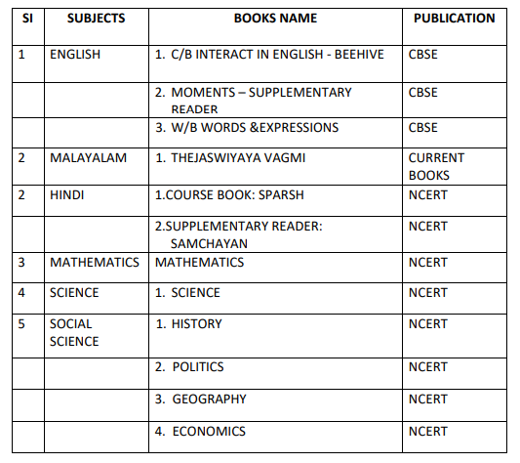
6 | COMPUTER | INFORMATION TECHNOLOGY | ORANGE

Academic session 2023-24
Class- 10
